Implementation Report

for

TRAFFIC ACCIDENTS ANALYSIS

Version 1.0 approved

Prepared by GROUP

10 / 08 / 2019

Table of Contents

Introduction 3

How has the weather influenced the specific types of accidents? 3

How has the number of traffic accidents changed over the years 4

Which accidents occur most frequently? 5

Days 5

During which time has the greatest number of accidents? 6

# Introduction

To clearly understand the traffic accident data of Denver state, we answer the few questions we described in the software design document (SDD) with the help of visualizations.

# How has the weather influenced the specific types of accidents?

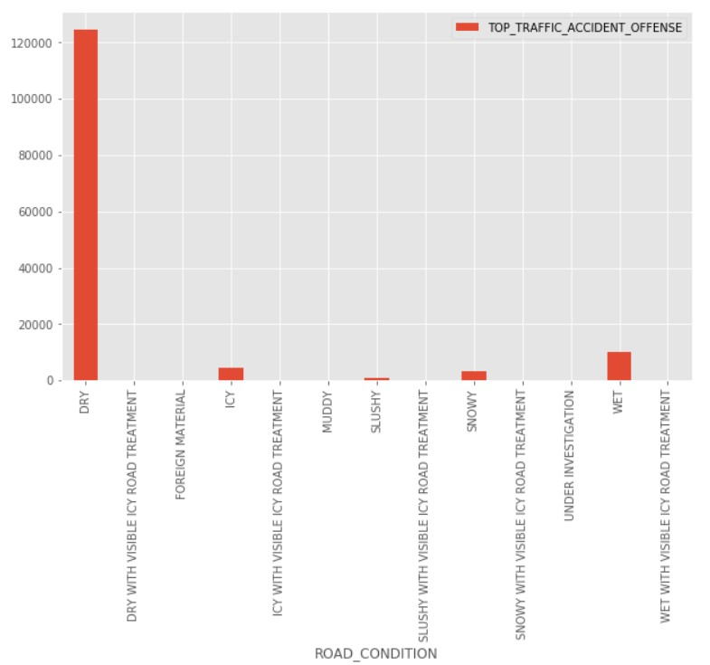

According to the bar graph, it can be concluded that more accidents happen during the dry season than during any other weather condition, because many drivers would like to drive under clear conditions hence many cars on road and many accidents. It is also evident that drivers also drive under tricky conditions which may lead to accidents that may not have happened if they had used public means. This indicates that people don’t know how to drive under bad weather conditions. Therefore, we would suggest that the Denver police department puts up programs to train public drivers that will drive under bad weather conditions in order to eradicate accidents that happen during those conditions (ICY, SNOW, WET).

How has the number of traffic accidents changed over the years

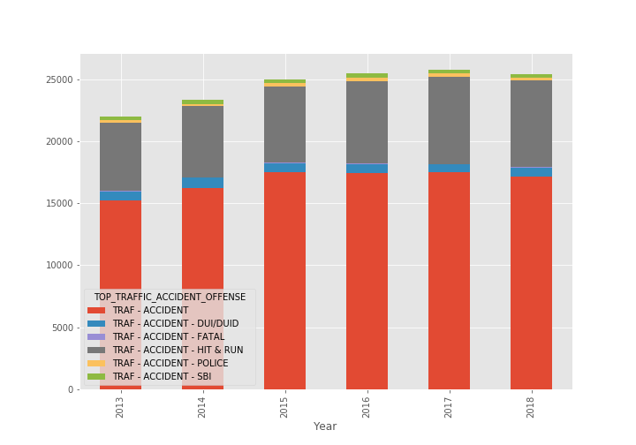

Figure above shows a stacked bar chart which explains the occurance of a particular accident type in a year. Taking an example of the bar representing the year 2013, the bar is divided into 6 colors with each color representing a particular accident type. The height each color fills up in bar, shows the number of accidents that have happened for that particular accident. The color red represents other traffic accidents, the color blue represents DUI/DUID, grey for hit & run, yellow for police and light green for SBI.

# Which accidents occur most frequently?

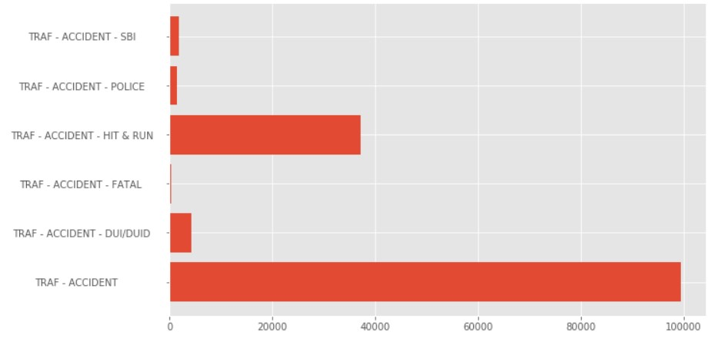

TRAF-ACCIDENT (small minor accidents) are recorded most frequently. It is therefore evident that Denver state has a lot of incompetent drivers which causes such many accidents, we therefore recommend that the traffic department of Denver state tightens the system used to issue out driving licenses to drivers.

# Days

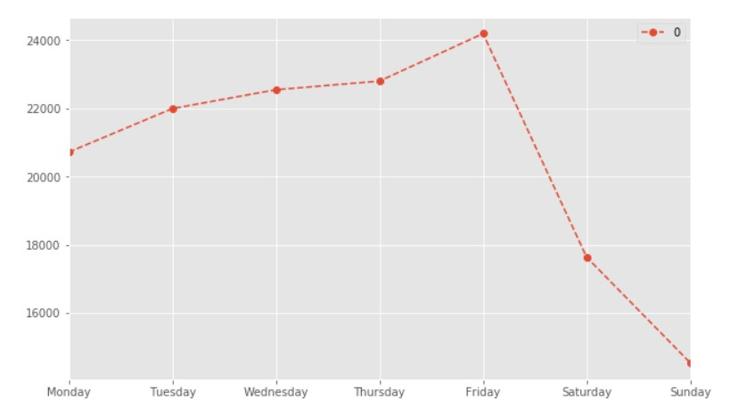

From the line graph it is evident that the number of accidents increase as the week progresses from Monday to Thursday and reach the peak on Friday then decreases through the weekend most probably because they drive a lot during the week going to work and also taking kids to the school. Friday has the greatest number of accidents most probably because drivers resort to drinking as a way of relieving stress they endured during the working days, and so may end up driving under the influence of alcohol leading to more accidents on Friday

# During which time has the greatest number of accidents?

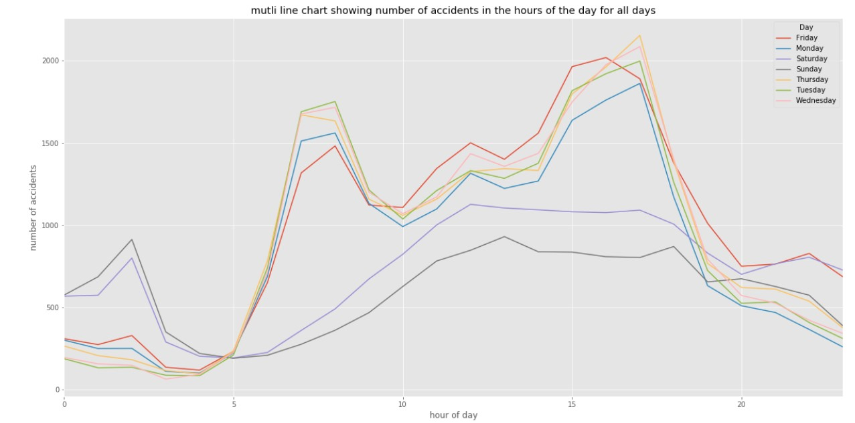

The numbers spike on Monday, Tuesday, Wednesday, Thursday and Friday between 3Pm and 5pm and drop between 8pm and 5am after which they rise. This indicates that more people drive between 3pm and 5pm which is attributed to the fact that people are going to work. The number of accidents on weekends Saturday and Sunday are less are the only spikes appear between 1am and 2am after which they decline gradually until they rise again at 5am.

This indicates that there are more drunkard drivers on the weekend between 1am and 2am, since most the people are not coming from work during that time period. This can be evidenced from the graph showing number of accidents vs time, there is a spike in the TRAF-ACCIDENT -DUI/DUID (drive under influence) in the time between 12am and 5am when most people are traveling from bars.

It would therefore be relevant if the Denver police department put patrol cars between 1am and 5am in order to reduce on the accidents that curb lives between those hours.

Hit and Run accidents are more evident in the morning hours when people are going to work and after work hours in the evening when people are leaving work, this indicates that these accidents are a result of traffic. Therefore, the police should find measures of reducing traffic in those hours in order to reduce on the number of accidents in those hours.

